1. Movie should have multiple media (Video or Image)

1.Create Table

Create table Media (Id Integer, Name text, Image blob)

2.Insert values

Insert into Media values ( 1, “Cartoon”, “C:\Users\Balaji grp\Downloads/avator”)

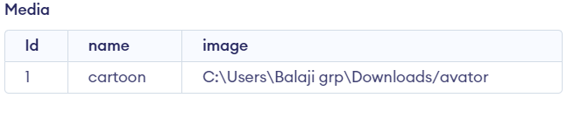

1. Movie can belongs to multiple Genre

1.Create Table

Create table Genre (Id Integer, Genre_Id Integer)

2.Insert values

Insert into Genre values (1, 101)

Insert into Genre values (1, 102)

Insert into Genre values (1, 103)

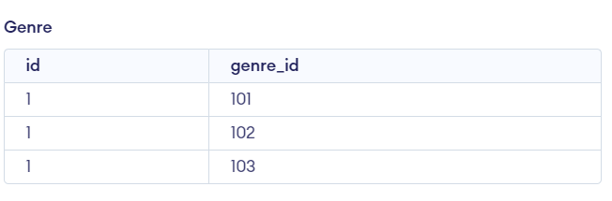

3.Create Table

Create table Movie_id (Id Integer, movies_name text)

4.Insert values

Insert into Movie_id values (1, “Money Heist ” )

Insert into Movie_id values (1, “Armour of God”)

Insert into Movie_id values (1, “Gumanji” )

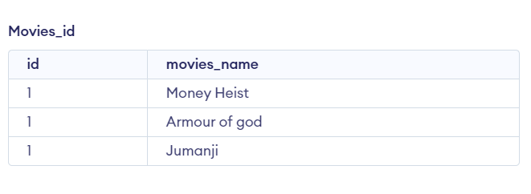

5.Select values

Select Genre_Id, movies_name from Genre join Movie_id on genre.id = movies_name.id

1. Movie can have multiple reviews and Review can belongs to a user

1.Create Table

Create table BoxOffice (Name text, Reviews text)

2.Insert values

Insert into BoxOffice values ( “Money Heist ”, “Good movie-Blockbuster” )

Insert into BoxOffice values ( “Armour of God” “Very good movie-1000crore club”)

Insert into BoxOffice values ( “Gumanji” “Average ” )

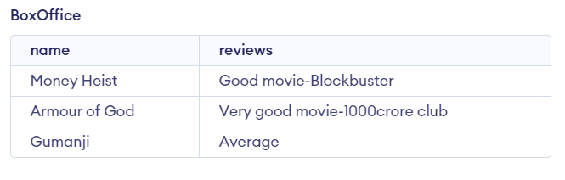

3.Altering Table

Alter table BoxOffice Add column Mov_Language text Default “English”

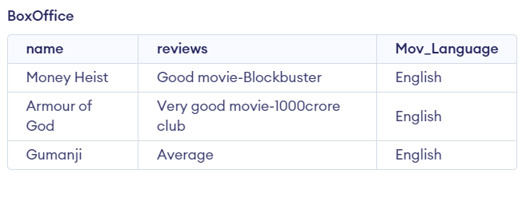

1. Artist can have multiple skills

1.Create Table

Create table Artist (Art_Name text, Skills text)

2.Insert values

Insert into Artist values ( “JackyJohn”, “Acting” )

Insert into Artist values ( “Rock” “Fighting”)

Insert into Artist values ( “Alvaro Morte” “Dancer” )

1. Artist can perform multiple role in a single film

3.Create Table

Create table Artist_role (role text, Movies text)

4.Insert values

Insert into Artist_role values ( “Hero”, “Armour of God” )

Insert into Artist_Role values ( “Negative-Shade” “Jumanji”)

Insert into Artist_Role values ( “Professor” “Money Heist” )

5.Insert values

Select * from Artist join Artist_role

